UNIT-3
Hop to Hop Delivery. Error Detection and Correction �Type of Errors, Redundancy, Detection ,Correction, Forward Error and Retransmission. Coding -Block Coding(Parity Chek Code and Hamming Code) and Cyclic Codes.� Framing, flow and error control, Protocols - Noiseless channels (Simplest , Stop and Wait) and Noisy channels(Stop and Wait and Piggy Backing) .

- Hop to Hop Delivery.
- The Hop-to-hop delivery (the node-to-node delivery) is the delivery between two nodes connected to the same network by a link. This job is carried out by the data link layer.
- A “hop” is the usual term used on the Internet to indicate the forwarding of a packet between a host and the next intermediate system. Frames can “hop” between Layer 2 switches.
- In hop-to-hop delivery, physical addresses of the devices are used to identify devices.
The format of a physical address depends on the network type.
(For example, Ethernet LAN technology use 48-bit (6-byte) addresses. Each Ethernet network device has a Network Interface Card (NIC) with its own unique hardware address that is normally written in hexadecimal notation) eg:07:01:02:01:2C:4B
- The physical addresses will change from hop to hop, but the logical addresses usually remain the same. For example in the below figure if Systems A is communicating with D ,at System A the frame contains physical address of Intermediate system B and at B it will be changed to the next intermediate node C's physical address. At C our frame's physical address will be changed to the physical address of D and thus our frame reaches its destination D. This is called hop to hop delivery.

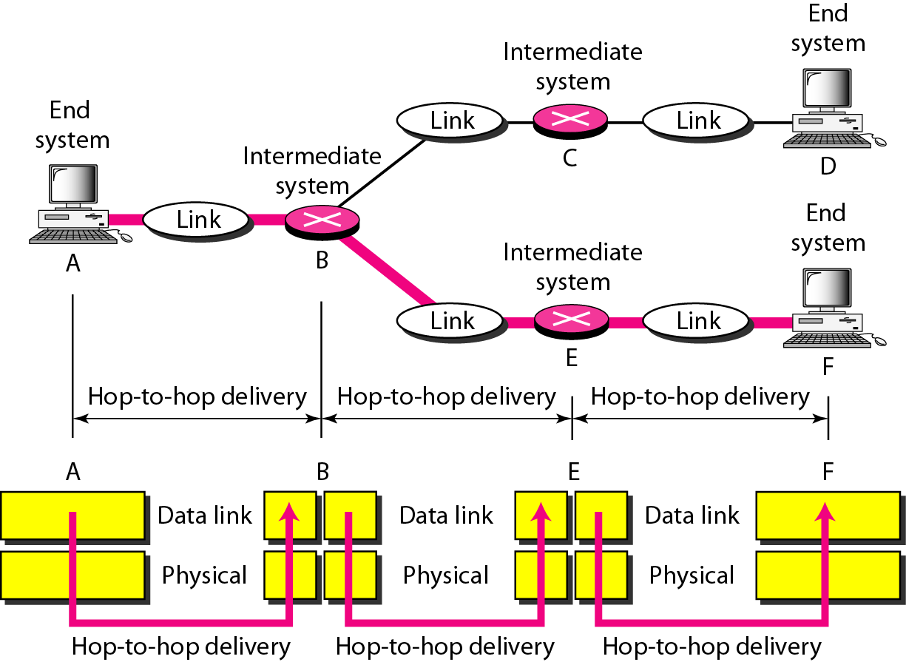

- Error Detection and Correction
Environmental interference and physical defects in the communication medium can cause random bit errors during data transmission. Error coding is a method for detecting and correcting these errors. Different error coding schemes are chosen depending on the types of errors expected and the communication medium's expected error rate.

  - Type of Errors
Whenever bits flow from one point to another, they may change because of interference. In a single-bit error, a 0 is changed to a 1 or a 1 to a 0. In a burst error, multiple bits are changed.
Single-Bit Error
The term single-bit error means that only 1 bit of a given data unit (such as a byte,
character, or packet) is changed from 1 to 0 or from 0 to 1.
Single-bit errors are very rare in serial data transmission. (Imagine data sent at 1 Mbps. This means that each bit lasts only 1/1,000,000 s,
or 1 )ls. For a single-bit error to occur, the noise must have a duration of only 1 )ls, which
is very rare; noise normally lasts much longer than this.
Burst Error
The term burst error means that 2 or more bits in the data unit have changed from 1 to 0
or from 0 to 1.
A burst error means that 2 or more bits in the data unit have changed.
Figure 10.2 shows the effect of a burst error on a data unit. In this case,
0100010001000011 was sent, but 0101110101100011 was received. Note that a burst
error does not necessarily mean that the errors occur in consecutive bits. The length of
the burst is measured from the first corrupted bit to the last corrupted bit. Some bits in
between may not have been corrupted.
A burst error is more likely to occur than a single-bit error. The duration of noise is
normally longer than the duration of 1 bit, which means that when noise affects data, it
affects a set of bits. The number of bits affected depends on the data rate and duration
of noise. For example, if we are sending data at I kbps, a noise of 11100 s can affect 10 bits; if we are sending data at I Mbps, the same noise can affect 10,000 bits.
  - Redundancy
The central concept in detecting or correcting errors is redundancy.
To detect or correct errors, we need to send extra (redundant) bits with data.
These redundant bits are added by the sender and removed by the receiver. Their presence allows the receiver to detect or correct corrupted bits.
Redundancy is achieved through various coding schemes
  - Error Detection
Error Detection means checking to see if any error has occurred. The answer is either yes or no.
Basic approach used for error detection is the use of redundancy ie, additional bits are added to data to detect errors.

Popular techniques are:
- Simple Parity check
- Two-dimensional Parity check
- Checksum
- Cyclic redundancy check
  - Error Correction
The correction of errors is more difficult than the detection.
- We need to know the exact number of bits that are corrupted and also their location in the message.
- The number of the errors and the size of the message are also important factors.

Error Correction can be handled in two ways.
- Backward error correction - the receiver can have the sender retransmit the entire data unit.
- Forward error correction - receiver can use an error-correcting code, which automatically corrects certain errors. Error-correcting codes require more redundant bits.
The number of bits required to correct multiple-bit or burst error is so high that in most of the cases it is inefficient to do so. For this reason, most error correction is limited to one, two or at the most three-bit errors.

- Coding
Redundancy is achieved through various coding schemes. The sender adds redundant bits through a process that creates a relationship between the redundant bits and the actual data bits. The receiver checks the relationships between the two sets of bits to detect or correct the errors. The ratio of redundant bits to the data bits and the robustness of the process are important factors in any coding scheme.
We can divide coding schemes into two broad categories: block coding and convolution coding.
we are studying only block coding here.

BLOCK CODING
In block coding, we divide our message into blocks, each of k bits, called datawords. We
add r redundant bits to each block to make the length n = k + r. The resulting n-bit blocks
are called codewords.
(With k bits, we can create a combination of 2^{k} datawords; with n bits, we can create a combination of 2^{n} codewords. Since n > k, the number of possible codewords is larger than the number of possible datawords.)
The block coding process is one-to-one; the same dataword is always encoded as the same codeword. This means that we have 2^{n} - 2^{k} codewords that are not used. We call these codewords invalid or illegal.

Hamming Distance
One of the central concepts in coding for error control is the idea of the Hamming distance. The Hamming distance between two words (of the same size) is the number of differences between the corresponding bits. We show the Hamming distance between two words x and y as d(x, y). The Hamming distance can easily be found if we apply the XOR operation on the two words and count the number of Is in the result. Note that the Hamming distance is a value greater than zero.
Let us find the Hamming distance between two pairs of words.
1. The Hamming distance d(000, 011) is 2 because 000 XOR 011 is 011 (two Is).
2. The Hamming distance d(10101, 11110) is 3 because 10101 XOR 11110 is 01011 (three Is).

Minimum Hamming Distance
Although the concept of the Hamming distance is the central point in dealing with error detection and correction codes, the measurement that is used for designing a code is the minimum Hamming distance. In a set of words, the minimum Hamming distance is the smallest Hamming distance between all possible pairs. We use dmin to define the minimum Hamming distance in a coding scheme. To find this value, we find the Hamming distances between all words and select the smallest one.

Find the minimum Hamming distance of the coding scheme
Solution We first find all the Hamming distances.
d(00000, 01011) = 3 d(01011, 10101) =4 d(00000, 10101) =3
d(0l011, 11110) = 3 d(00000, 11110) = 4 d(10101, 11110) =3

The dmin in this case is 3.

Three Parameters
Any coding scheme needs to have at least three parameters: the codeword size n, the dataword size k, and the minimum Hamming distance dmin. A coding scheme C is written as C(n, k) with a separate expression for dmin.
For example if we write as C(3, 2) with dmin =2 means dataword of size 2 is appended with a bit to produce codeword of length 3 and minimum hamming distance dmin of this coding scheme is 2.

For example if we write as C(5, 2) with dmin =3 means dataword of size 2 is appended with 3 bits to produce codeword of length 5 and minimum hamming distance dmin of this coding scheme is 3.

Hamming Distance and Error
Before we explore the criteria for error detection or correction, let us discuss the relationship between the Hamming distance and errors occurring during transmission. When a codeword is corrupted during transmission, the Hamming distance between the sent and received codewords is the number of bits affected by the error. In other words, the Hamming distance between the received codeword and the sent codeword is the number of bits that are corrupted during transmission. For example, if the codeword 00000 is sent and 01101 is received, 3 bits are in error and the Hamming distance between the two is d(00000, 01101) =3.
Minimum Distance for Error Detection
Now let us find the minimum Hamming distance in a code if we want to be able to detect up to s errors. If s errors occur during transmission, the Hamming distance between the sent codeword and received codeword is s. If our code is to detect up to s errors, the minimum distance between the valid codes must be s + 1 ie. dmin =s + 1 in our coding scheme.
To guarantee the detection of upto s errors in all cases, the minimum Hamming distance in a block code must be dmin =s+1.
To guarantee correction ofup to t errors in all cases, the minimum Hamming distance in a block code must be dmin = 2t+ 1.

A code scheme has a Hamming distance dmin == 4. What is the error detection and correction capability of this scheme?
This code guarantees the detection of up to three errors (s = 3), but it can correct up only one error.

Parity Check Code

Simple Parity Checking or One-dimension Parity Check
The most common and least expensive mechanism for error- detection is the simple parity check. In this technique, a redundant bit called parity bit, is appended to every data unit so that the number of 1s in the unit including the parity becomes even.
Blocks of data from the source are subjected to a check bit or Parity bit generator , where a parity of 1 is added to the block if it contains an odd number of 1’s and 0 is added if it contains an even number of 1’s. This scheme makes the total number of 1’s even, that is why it is called even parity checking. At the receiving end the parity is checked. If the parity of received code word is 'even' ,it is accepted and if it is 'odd' the received word is rejected. Considering a 4-bit word, different combinations of the data words and the corresponding codewords are given in Table given below.

Check parity

we are discussing here the even-parity checking, where the number of 1’s should be an even number. It is also possible to use odd-parity checking, where the number of 1’s should be odd.
Performance
An observation of the table reveals that to move from one code word to another, at least two data bits should be changed. Hence these set of code words are said to have a minimum distance (hamming distance) of 2, which means that a receiver that has knowledge of the code word set can detect all single bit errors in each code word. However, if two errors occur in the code word, it becomes another valid member of the set and the decoder will see only another valid code word and know nothing of the error. Thus errors in more than one bit cannot be detected. In fact it can be shown that a single parity check code can detect only odd number of errors in a code word.
Two-dimension Parity Check
Performance can be improved by using two-dimensional parity check, which organizes the block of bits in the form of a table. Parity check bits are calculated for each row, which is equivalent to a simple parity check bit. Parity check bits are also calculated for all columns then both are sent along with the data. At the receiving end these are compared with the parity bits calculated on the received data. This is illustrated in Fig. 3.2.4.

Performance
Two- Dimension Parity Checking increases the likelihood of detecting burst errors. As we have shown in Fig. 3.2.4 that a 2-D Parity check of n bits can detect a burst error of n bits. A burst error of more than n bits is also detected by 2-D Parity check with a high-probability. There is, however, one pattern of error that remains elusive. If two bits in one
data unit are damaged and two bits in exactly same position in another data unit are also damaged, the 2-D Parity check checker will not detect an error. For example, if two data units: 11001100 and 10101100. If first and second from last bits in each of them is changed, making the data units as 01001110 and 00101110, the error cannot be detected by 2-D Parity check.

Hamming Codes
Hamming codes are error-correcting codes. These codes were originally designed with dmin = 3, which means that they can detect up to two errors or correct one single error
For example, if m =3, then n = 7 and k= 4. This is a Hamming code C(7, 4) with dmin =3. Table 10.4 shows the datawords and codewords for this code.

A copy ofa 4-bit dataword is fed into the generator that creates three parity checks r0, rl and r2 as shown below:

r0=a2+al +a0
rl =a3 +a2 + al
r2=a1+a0+a3

In other words, each of the parity-check bits handles 3 out of the 4 bits of the dataword. The total number of 1s in each 4-bit combination (3 dataword bits and 1 parity bit) must be even.
The checker in the decoder creates a 3-bit syndrome (s2s1s0) in which each bit is the parity check for 4 out of the 7 bits in the received codeword:
So =b2+ b1 +b0+q0 111 S2S1S0
Sl =b3 + b2+ b1 +ql
S2 = bl +b0+b3 +q2

The equations used by the checker are the same as those used by the generator with the parity-check bits added to the right-hand side of the equation. The 3-bit syndrome creates eight different bit patterns (000 to 111) that can represent eight different conditions. These conditions define a lack of error or an error in 1 of the 7 bits of the received codeword.

Logical decision made by the correction logic analyzer at the decoder

Syndrome 000 001 010 011 100 101 110 111
Error None q0 ql b2 q2 b0 b3 bl

Note that the generator is not concerned with the four cases in red in the above table because there is either no error or an error in the parity bit.
In the other four cases, 1 of the bits must be flipped (changed from 0 to 1 or 1 to 0) to find the correct dataword. The syndrome values in Table 10.5 are based on the syndrome bit calculations. For example, if qo is in error, So is the only bit affected; the syndrome, therefore, is 001. If b2 is in error, So and s1 are the bits affected; the syndrome, therefore is OIl. Similarly, if bI is in error, all 3 syndrome bits are affected and the syndrome is 111.

Cyclic Redundancy Checks (CRC)
This Cyclic Redundancy Check is the most powerful and easy to implement technique. CRC is based on binary division. In CRC, a sequence of redundant bits, called cyclic redundancy check bits, are appended to the end of data unit so that the resulting data unit becomes exactly divisible by a second, predetermined binary number. At the destination, the incoming data unit is divided by the same number. If at this step there is no remainder, the data unit is assumed to be correct and is therefore accepted. A remainder indicates that the data unit has been damaged in transit and therefore must be rejected. The generalized technique can be explained as follows.
If a k bit message is to be transmitted, the transmitter generates an r-bit sequence, known as Frame Check Sequence (FCS) so that the (k+r) bits are actually being transmitted. Now this r-bit FCS is generated by dividing the original number, appended by r zeros, by a predetermined number. This number, which is (r+1) bit in length, can also be considered as the coefficients of a polynomial, called Generator Polynomial. The remainder of this division process generates the r-bit FCS. On receiving the packet, the receiver divides the (k+r) bit frame by the same predetermined number and if it produces no remainder, it can be assumed that no error has occurred during the transmission. Operations at both the sender and receiver end are shown in Fig.
This mathematical operation performed is illustrated in
By dividing a sample 4-bit number by the coefficient of the generator polynomial x3+x+1, which is 1011, using the modulo-2 arithmetic. Modulo-2 arithmetic is a binary addition process without any carry over, which is just the Exclusive-OR operation. Consider the case where k=1101. Hence we have to divide 1101000 (i.e. k appended by 3 zeros) by 1011, which produces the remainder r=001, so that the bit frame (k+r) =1101001 is actually being transmitted through the communication channel. At the receiving end, if the received number, i.e., 1101001 is divided by the same generator polynomial 1011 to get the remainder as 000, it can be assumed that the data is free of errors.

Performance
CRC is a very effective error detection technique. If the divisor is chosen according to the previously mentioned rules, its performance can be summarized as follows:
- CRC can detect all single-bit errors
- CRC can detect all double-bit errors (three 1’s)
- CRC can detect any odd number of errors (X+1)
- CRC can detect all burst errors of less than the degree of the polynomial.
- CRC detects most of the larger burst errors with a high probability.

Checksum
- In checksum error detection scheme, the data is divided into k segments each of m bits.
- In the sender’s end the segments are added using 1’s complement arithmetic to get the sum. The sum is complemented to get the checksum.
- The checksum segment is sent along with the data segments.
- At the receiver’s end, all received segments are added using 1’s complement arithmetic to get the sum. The sum is complemented.
- If the result is zero, the received data is accepted; otherwise discarded.

